 | Minutes of the Planning Committee Meeting of 26th January 2016 held in the Reading Room, Church Road, Buxted at 7.30pm.
 | Present: Cllrs. (Chairman) Mulvagh, Blandford, McQuarrie, Rose and Sheard. Also in attendance Miss B Macklen, Clerk to Buxted Parish Council
 | Public: None at this meeting
1. | Apologies: Apologies were received and accepted from Cllr. Harding and clerk to parish council Claudine Feltham
2. | Minutes: The minutes of the meeting of 12th January 2016 were approved and signed as a correct record by the Chairman.
3. | Declaration of Members Interests in respect of items on this agenda  Cllrs. Rose, McQuarrie and Mulvagh declared a personal interest in item 4.4 by virtue of either knowing the applicant of requenting the Buxted Inn.
4.  4.1  4.2  4.3  4.4 | Planning Applications  Application No. WD/2015/2712/F  Location: Saxon Court, Pound Green, Buxted, TN22 4DT  Description: Ground floor fixed solar array.  Applicant: Abbey Care Saxon Ltd, Saxon Court, Pound Green, Buxted, TN22 4DT  Agent: Owen Powell Architects, 82 Gloucester Road, Brighton, BN1 4AP.  No objection – recommend approval. The site is well screened and will have no adverse impact on either neighbouring properties or the locality.  Application No. WD/2015/2798/F  Location: Sandrocks Farmhouse, Limes Lane, Buxted, TN22 4PE.  Description: Two storey side extension and additions.  Applicant: Mr & Mrs S Law, Sandrocks Farmhouse, Limes Lane, Buxted, TN22 4PE.  Agent: Mr M Hill, Croom Cottage, London Road, East Hoathly.  No objection – recommend approval.  Application No. WD/2015/2843/F  Location: Klomona, Five Ash Down, Uckfield, TN22 3AP.  Description: Re-application of expired permission for house extension and loft conversion plus enlargement of existing garage.  Applicant: Mr Brian Muddle, Klomona, Five Ash Down, Uckfield, TN22 3AP.  Agent: RDT Design Associates, Ridegwood, 150 Victoria Avenue, Hastings.  No objection – recommend approval. A large extension, but it will have no adverse impact on neighbouring properties.  Application No. WD/2015/2800/F  Location: The Buxted Inn, High Street, Buxted, TN22 4LA.  Description: Alterations to front of public house and internal alterations.  Applicant: Mr Jason Bailey, The Buxted Inn, High Street, Buxted, TN22 4LA.  Agent: Peter Cook, Passfield, Framfield Road, Buxted.  No objection – recommend approval. Although the parish council understand the circumstances surrounding why work was started, it would still comment that it is always preferable to gain permission before starting works.
5.  5.1  5.2  5.3 | To discuss any planning applications received from Wealden District Council after the publication of the agenda that are available on the District Planning website  Application No. WD/2016/0027/FR  Location: Heatherdene House, Buxted Wood Lane, Buxted, East Sussex, TN22 4QE  Description: Part retrospective ground based photovoltaic solar arrays, access, grid connection and associated works.  Applicant: Mr M Johnson  Agent: Parker Dann  Objection – Recommend refusal. The proposed development is oversized for the proposed domestic electrical supply needs for Heatherdene and therefore is of small scale commercial nature which is entirely omitted from the planning application. Moreover it is considered that a correct Landscape Visual Impact Assessment has not been carried out. Although the NPPF guidelines have been roughly followed, and it is unclear, how one determines of ‘modest size’ it is clear that not enough due consideration was given to the impact of this array in the local landscape. It is also regretted that this is yet another retrospective planning application.  A visit to this site and the vicinity was carried out on the afternoon of Sunday 24th January and noted that work on the site had already commenced. It would seem that a good many panels have already been erected and this is a retrospective planning application. Although the fact that construction of the solar panels has already commenced, without planning permission, this proved helpful in assessing that these panels do have an impact from the surrounding landscape. This was in spite of the fact that the visibility and light levels were poor. Had the sun been shining the effect of these panels being visible in the landscape would have been even greater. A return visit was made the following morning, 25th January when, in bright sunlight, the panels are clearly visible and do have a considerable impact within the wider landscape of this Low Weald Landscape, in particular from a residential road, Redbrook Lane, to the west of the installation and on higher ground above it. The dwellings along Redbrook Lane, at this point are built with extensive view over the valley looking eastwards towards the array.  In the documentation is a letter from Kelvin Williams to a Mr Best (sent by email) referring to a meeting on the 11th November 2015 in which the provision of a solar panel display in a paddock within the residential curtilage of Heatherdene was discussed. It would appear that the decision as whether this array would have any impact the immediate local landscape, arrived at in this letter, was made on the evidence provided by an aerial photograph and description of the site. Kelvin Williams also goes on to state that ‘it would be sensible to include a short statement on the visual impacts of the development, outside of a designated landscape, but not need to be a full Landscape Visual Assessment’. Whilst it is correct to state that the field in which a number of the solar panels have already been built is well screened by an existing field hedge and any view of the panels from Buxted Wood Lane is limited. It is not true of the views into the site from Redbrook Lane.  It would appear that no consideration has been taken of the impact that this array will have in the wider landscape as seen from the dwellings at the end of Redbrook Lane, such as Redbrook House, Bracken Cottage and Hilden Vale. These houses are set higher up on a slight ridge above the fields where Heatherdene and the panels are located. Any additional screening would not screen these panels from view. It is accepted that this site visit was carried out in winter when the views are clearer but it does not alter the fact that it is untrue to say this array will have no visual impact in the landscape.  Redbrook Lane is a Bridle Way and, as such, forms part of the long distance footpath, the Vanguard Way. Further up this lane, towards the A272, this array is clearly visible from this footpath, and no amount of screening, at any time of year will mask the installation.  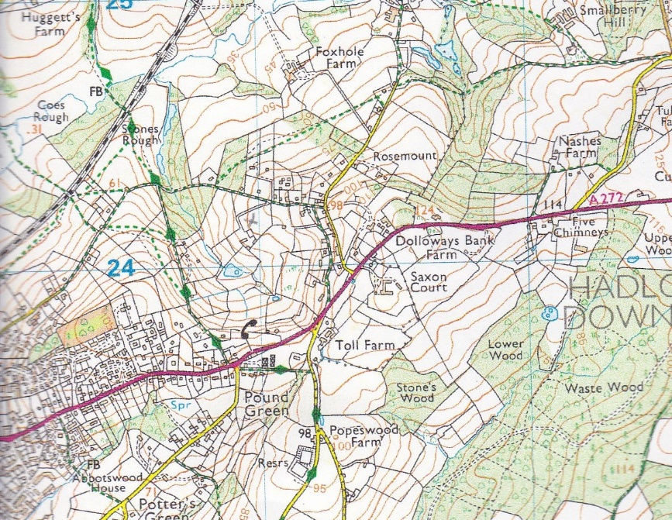  In the accompanying design and access statement 4.17 it states that the accompanying detailed landscaping plan ensures the proposal assimilates well within the landscape and has no undue adverse impact on the character and appearance of the countryside when complete. True, perhaps, in the immediate vicinity of the installation but blatantly untrue when seen from points along Redbrook Lane. 4.21 also sates that the proposed development would not dominate the landscape or views from public footpaths and is not appropriate to comment that the proposed dwelling of ‘Heatherdene House itself is far more likely to draw the eye given its considerable architectural merit and fairly significant size’.  4.23 ‘The array will be carefully landscaped to minimise the landscape impact of the proposal and already benefits from significant, well established vegetation, around the perimeter of the paddock…’ This only is true for the immediate environment around the array and would seem only to benefit the property itself. Any new planting will not minimise the impact of this array in the landscape as viewed from Redbrook Lane, as can been seen from the accompanying map. Redbrook Lane is set considerably higher in the landscape than the land under discussion.  4.24’ Views from public footpaths are very limited. They are prevented by intervening vegetation and the modest size of the display’. The first statement not true and how is an array of this size considered to be modest in the small scale nature of the landscape of the Low Weald?  Whilst the planning application states that this a ‘modest’ array it is noted that this installation will consist of 4 rows of arrays in the region of 50 photovoltaic panels. Does this mean there might be more than 50 panels? Whilst Buxted Parish Council is not an expert in such matters would this number of panels generate electricity beyond the needs of the adjacent residence and therefore there might be an excess of electricity generated and thence sold on? As a comparison, Buxted Parish Council also considered an application (on the same evening) for a dual panel mounting system, just one panel long which would deliver the required output to not only heat the nursing home but make the project commercially viable. Are four panels therefore justified in this visually intrusive position and would it not set a precedent for others? Also the planning application does not actually admit to the numbers of panels which will be finally seen in this location.  Given that a t Landscape Visual Impact Assessment on the surrounding landscape has not been carried out, Buxted Parish Council refuse to endorse retrospective planning permission on these grounds. Whilst WDC may think the impact of these solar panels is acceptable within this landscape it hoped that due care and considerations, and that NPPF guidelines are correctly followed. At the very least this proposal should admit the effect the array will have in the landscape and Wealden District Council may them deem these to be acceptable.  Will a site visit be carried out and consideration given to those residents living in the lower end of Redbrook Lane and a suitable Landscape Visual Impact Assessment be carried out?  Whilst Buxted Parish Council would support small scale alternative energy developments, sensitively located they would like to know what policy Wealden District Council has in regard to these developments. This includes some of our concerns over this current application (WD2016/0027/FR), and any future ones. These are:  - Arrays designed to a size which would generate electricity in excess to the accompanying dwelling’s needs.  - An honest and factually correct Landscape and Visual Impact Assessment is carried out  In addition has WDC considered the accumulative effect an increasing number of these arrays would have on the small scale and intimate landscape in areas such as the Low Weald? At what point would they have to consider no further permission is given for such applications? Would it be sensible to limit the size of any installation so it provides the needs for the attached dwelling only?  Application No. WD/2016/0062/F  Location: Russetts, Burnt Oak Road, High Hurstwood, TN22 4AE  Description: Rooms in roof with front and rear roof lights and extension to existing stair enclosure.  Applicant: Mr Packer, Russetts, Burnt Oak Road, High Hurstwood, TN22 4AE  Agent: Jon Andrews Ltd, Chilcote, Threals Lane, West Chiltington, RH20 2RF  No objection – recommend approval.  Application No. WD/2016/0137/F  Location: 12 Olives Pit Lane, Five Ash Down  Description: Loft conversion with one roof light at the front and two roof lights at the rear.  Applicant: Mr Benson, 12 Olives Pit Lane, Five Ash Down, TN22 3EZ.  Agent: Albion Lofts, 9 Allington Farm, Allington Lane, Offham, Nr Lewes.  No objection – recommend approval.
6. | Matters for information: Noted
7. | Any other matters properly notified:  Cllr Rose reported that in a conversation with Bob Lake, it was mentioned that Hadlow Down Parish Council are investigating the possibility of part of the village being designated for certain development under a Neighbourhood Plan, which would then allow them to apply for a Community Right to Build Order to carry out development without necessarily needing planning permission. There is a vast amount of information available on the www.mycommunity.org.uk regarding this and other community projects. However, it is noted that every neighbourhood plan or community right to build project does have to first be assessed by the local planning authority and does have to be in conformity with local and national policy – it should complement existing strategic policies. Clerk requested to look into the scheme although it was thought that as permission has been granted, Buxted would not be allowed to apply for the community right to build, but it might be worth looking into the process for grant opportunities.  The clerk was asked to put an article on the website advising members of the public how to comment on planning applications on the Wealden website as it has been advised by a councilor that people are not aware of how to do this.
8. | Announcements: None this meeting.
 | The meeting closed at 7.55p.m.

